Bandit level 1 to level 2
For login in to level1 use the username as
There will slight change for the username in each level, and the change is bandit level number.
Then use ls command for listing the files.
After using the ls command there exit a file called - .
Then use cat command for displaying its content.
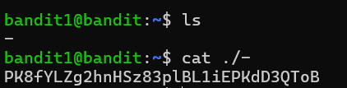
Then you will get the password for login id of level2.

